**Resources page:-**

There are two different types of resource pages. One of them is forecasted resource page and the other is actual resource page.

**Forecasted** resource page:-

When a user (IBG, IBU, PGM, Admin) creates a new project then he will be redirected to this forecasted resource page. In this page he can enter the values of resources at the start of the project.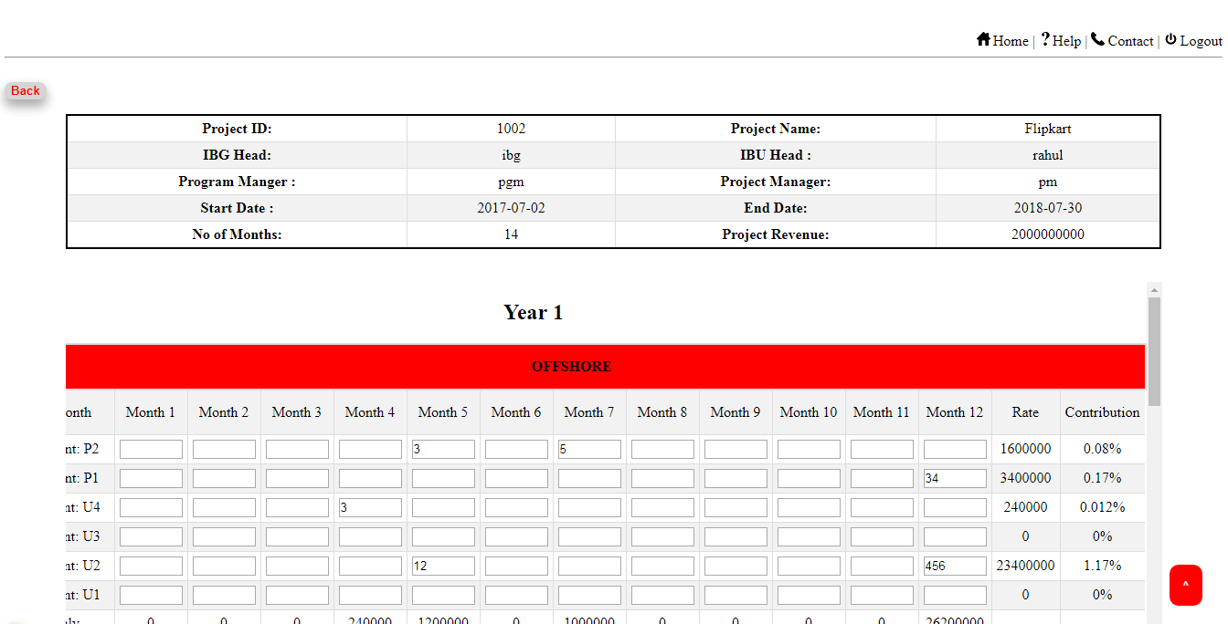

The users like Admin, IBG, IBU, program manager will be able to access this page (This is an editable page) when they need to create a new project. The user needs to enter the forecasted resource number for every month of that particular band. After saving this page the values of this page will be inserted or stored into the database. These saved values are retrieved from the database and able to calculate the rate (cost) and contribution of that particular project. The complete details of that particular project will be displayed on the top of the forecasted table.

The **Back** button will helps in redirecting to the previous page.

The **Home** hyperlink will redirect to Home page of that particular user.

The **Contact** hyperlink will redirect to the contact page.

The **Logout** hyperlink will redirect to the index page and further the user cannot use their account till they again sign in.

The **Top** button helps the user to reach the top of the page.

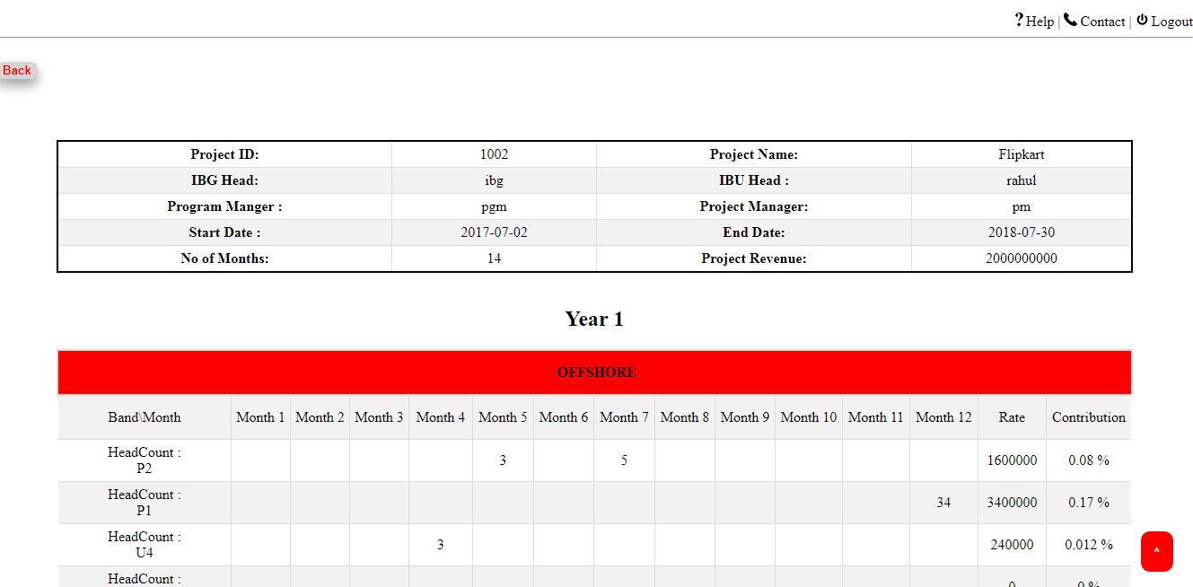**Actual** resource page:-

This is similar to forecasted page and the user cannot enter the values into this table because this is not editable. Here the values are retrieved directly from database. The data will be entered into database with the help of excel file upload process. This upload can be done only by the admin.